Vitoguide: Digital service center with new functionalities
The fastest way for specialist partners to contact our Technical Service department

The apartment’s cold, the customer’s on your back – and you need expert advice as soon as possible to fix the issue. With this in mind, the new version of the Vitoguide digital service center now provides the fastest way for specialist partners to contact Viessmann’s Technical Service department. The innovative solution to monitor heating systems therefore offers homeowners an even higher degree of security and enables specialist partners to process service call-outs more quickly. The result? Time and costs saved – and a happy customer.
Direct interface to the Technical Service department
The most recent Vitoguide functions make clear the extraordinary benefits of heat generator connectivity. If a specialist partner receives an automatic message to their digital service center because their customer’s system has developed a fault, they can now call the Technical Service department directly or arrange a call back at a convenient time. This wait to speak with a specialist advisor – which is clearly shown to the partner – is thereby kept to a minimum.
In addition, all relevant data relating to the customer system in question is automatically transferred. This saves time-consuming tasks such as entering serial numbers and automatically allocates the call to an advisor specialized in that field in the Technical Service department.
Error codes displayed from the control or combustion system
While the first version of Vitoguide provided specialist partners with operating data, such as temperatures and switching times, from the customers’ system connected, version 2.0 also displays the error codes issued by the control or combustion system. This functionality has been created in response to requests from numerous specialist partners. Ongoing use and feedback from specialist heating partners will decide the course of future improvements to the app and the implementation of further parameters. Of course, the app continues to show operating data. How this data is displayed can be directly and intuitively configured.
More information and easier to use
The clearly structured Vitoguide dashboard provides an overview of all customer systems, sorted according to their status. By clicking on the selected system, specialist partners can view detailed information on its current status. Partners are now also able to consult previous adjustments and error messages in chronological order. Then, on the basis of this information, they can make precise adjustments to parameters such as temperatures, heating curves and heating times, online and as required – thereby avoiding the need for a time-consuming journey. If necessary, they can also easily change the heat generator’s serial number and other user details.

Links to other applications
Of course, all other applications – such as the replacement part app, the package configuration tool, the schematic browser and the ViBooks central document search – remain fully available. Furthermore, the user interface can easily be expanded to include new functions important for the specialist partner’s work.

Advantages for trade partners
- Customer loyalty thanks to individual service offers
- Flexible planning thanks to early notification of potential faults and pending maintenance
- Saves time and costs by enabling partners to perform many service tasks from their own desk
- Service app integrated for fast access to the Technical Service department
- Contact the Technical Service department or request a call back via the app – all required system data transferred/provided
- System reporting, error notification and replacement part analysis
- Notifications and errors sorted according to urgency
- View and sort system history

Advantages for homeowners
- Maximum security through system monitoring by specialist partner
- Potential faults identified and resolved ahead of time
- Fast and effective support from a specialist partner if worst comes to worst
- Minor servicing tasks can be performed without anyone needing to be at home
- Five-year guarantee when connecting the system and support from a specialist partner via Vitoguide

Images / captions

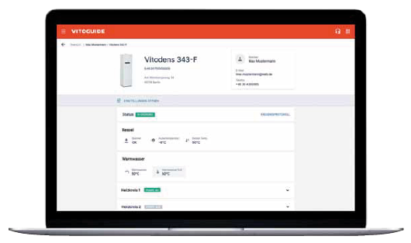
Image 1: Viessmann’s Vitoguide – the innovative online solution to monitor heating systems – now enables specialist partners to process service call-outs more quickly, therefore offering homeowners an even higher degree of security.

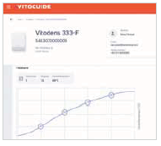
Image 2: If necessary, specialist partners can use Vitoguide to make precise adjustments to the heating curve and other parameters online, thereby optimizing the system without having to make a time-consuming journey.

March 2019

Viessmann Werke GmbH & Co. KG
35107 Allendorf (Eder)
Tel.: +49 (0)6452 702533
info-pr@viessmann.de
www.viessmann.de

