Vitocal 333-G and 222-G: New compact heat pumps for modern single-family homes
Highly efficient, space-saving and particularly quiet

For new-build homes, ensuring high-efficiency DHW generation is at least as important as ensuring rooms are heated while conserving as much energy as possible. This is due to the fact that, although recent years have seen domestic heating requirements fall markedly thanks to continued improvements in home insulation, energy demand for DHW generation has remained the same or even increased. Two new compact heat pumps – the Vitocal 333-G and the Vitocal 222-G – are effective in both regards, offering maximum efficiency in terms of both room heating and DHW generation. The only compact heat pumps on the market, they are classed in energy efficiency category A+ for DHW generation. With the best tapping rates, these pumps offer the maximum possible hot water convenience. What’s more, they take up hardly any space in the home and, as the quietest devices of their type, are almost silent in operation.

Vitocal 333-G: New generation of devices with modern output control
The Vitocal 333-G is available in two output levels: 1.7 to 8.6 kilowatts and 2.4 to 11.4 kilowatts. Thanks to its modern inverter technology, the new Vitocal 333-G compact pump is the most efficient solution for new builds. The output-controlled compressor adjusts the heating output from the brine/water heat pump according to the building’s current heat demand. The benefits of the new technology are particularly evident in partial load operation: continuous output control reduces the number of start/stop cycles compared to conventional heat pumps, thereby providing a higher seasonal performance factor.

Vitocal 222-G: Proven technology with additional customer benefits
The Vitocal 222-G compact heat pump is a more affordably priced alternative to the 300 series model. With constant heat output in three output levels between 5.8 and 10.4 kilowatts, the Vitocal 222-G is also designed for new single-family homes. Alternating compressor operation adjusts heat generation according to current heat demand. Meanwhile, the RCD system and electronic expansion valve ensure a high level of efficiency.

Hot water convenience to cope with the highest demands
Both compact pumps feature a newly developed 220-liter steel DHW cylinder with CeraProtect enamel coating. In the Vitocal 333-G, it offers a tap volume in excess of 300 liters at a tapping temperature of 40 °C. If required, hot water can also be provided at 60 °C without the need for electrical post-heating. This ensures a high degree of hot water convenience that also covers the highest demands, such as simultaneous hot water requirements from various taps. The maximum tap volume of the Vitocal 222-G is only slightly lower at 296 liters.
As an optional extra, a solar thermal system can be connected in DHW generation via a solar heat exchanger module.

Minimized operating noise for installation close to living areas
The heat pump modules also feature exceptional soundproofing, allowing the compact pumps to be operated without any problems even in the immediate vicinity of living spaces. The complete encapsulation screens the cooling module and hydraulics from their surroundings, while the new connection concept ensures vibration isolation. With sound emissions of just 41 dB(A) (according to the ErP Directive at B0/W55 °C), the Vitocal 333-G is one of the quietest brine/water heat pumps on the market. The Vitocal 222-G, which produces sound emissions of only 46 dB(A) (at B0/W55 °C) is also among the quietest devices of its type.

Ease and comfort all year round thanks to ‘natural cooling’ and Vitovent home ventilation
Comfortable room conditions at all times of year are an important requirement for many homeowners. Cooling rooms on warm summer days not only enhances comfort during the day but also helps to ensure a pleasant, relaxing night’s sleep. Thanks to their ‘natural cooling’ function, the compact heat pumps are also able to cool the house while conserving energy. In addition, the natural cooling box (accessory) dissipates the heat from rooms into the ground.
Home ventilation is indispensable, especially in the case of new buildings with an air-tight building envelope. The combination of a compact heat pump with a central home ventilation system, such as the Vitovent 300-W or Vitovent 300-F, ensures a constant supply of fresh, clean air in all rooms. Both devices are easy and convenient to operate centrally using either the heat pump controller itself or an optional remote control.

Easy to operate – including online control options
The Vitocal 333-G and 222-G are easy and intuitive to operate thanks to the pumps’ Vitotronic 200 control. The graphic display communicates information in clear, easy-to-understand terms. An Internet interface, Vitoconnect (accessory), makes it possible to control the devices online using a smartphone (iOS or Android) and the free ViCare app.
In addition, homeowners who engage a specialist partner for the online monitoring service also receive a guarantee extension from two to five years. The specialist partner only needs the Vitoguide digital service tool to do so.

Set it down, connect it up – and that’s all!
The pumps are particularly easy to transport and install. With their small footprint of less than 0.5 square meters, the Vitocal 333-G and Vitocal 222-G also fit easily in tight, narrow spaces. To facilitate their transport and delivery, the cooling circuit module can be removed from the device in just a few simple steps and then transported separately. Hydraulic and electrical plug-in connectors make installing and removing the module particularly straightforward. Thanks to the flexible connection concept, the compact pumps can be connected either to the left or the right. This feature allows the installer to adapt the pump to the specific installation location without any difficulties.
Advantages for trade partners
- Easy to transport thanks to option to remove the cooling circuit module quickly using plug-in connectors
- Easy to adapt to the specific installation location thanks to flexible connection concept
- All maintenance-related components accessible from the front
- Simplified spare part stockage through frequent use of carry-over parts
- Matching accessories for ventilation, cooling and solar heating

Advantages for homeowners
- Very high degree of hot water comfort through drinking water temperature of up 60 °C and very high tap capacity of 300 liters
- Very low operating costs thanks to highly efficient DHW generation – efficiency category A+ for DHW
- Barely audible, including when installed near living spaces
- Compact dimensions and small footprint free up space in the home
- Highly convenient operation: heating, cooling, hot water and ventilation via integrated Vitotronic control
- Increased use of self-generated electricity from photovoltaic systems thanks to the heat pump’s deep output modulation (Vitocal 333-G)
- Internet-capable thanks to Vitoconnect (accessory) and ViCare app

Technical data (Vitocal 333-G)
- Output: 1.7 – 8.6 kW and 2.4 – 11.4 kW (modulating)
- Capacity: 220 liters
- Max. tap volume: 306 liters at tapping temperature of 40 °C
- DHW temperature: up to 60 °C without electrical post-heating
- Flow temperature: up to 65 °C
- COP: up to 4.8 (according to EN 14511 at B0/W35 °C)
- SCOP (Seasonal Coefficient of Performance): up to 5.5 (according to EN 14825: cold climate / low temperature applications)
- Sound power level: 41 dB(A) (according to the ErP Directive at B0/W55 °C)
- Energy efficiency category: A+++
- DHW energy efficiency category: A+

Technical data (Vitocal 222-G)
- Output: 5.8 – 10.4 kW
- Capacity: 220 liters
- Max. tap volume: 296 liters at tapping temperature of 40 °C
- DHW temperature: up to 58 °C without electrical post-heating
- Flow temperature: up to 65 °C
- COP: up to 4.8 (according to EN 14511 at B0/W35 °C)
- SCOP (Seasonal Coefficient of Performance): up to 5.4 (according to EN 14825: cold climate / low temperature applications)
- Sound power level: 46 dB(A) (according to the ErP Directive at B0/W55 °C)
- Energy efficiency category: A++
- DHW energy efficiency category: A+

Delivery date
The new Vitocal 333-G and 222-G compact heat pumps are available for delivery from April 2019.

Images / captions
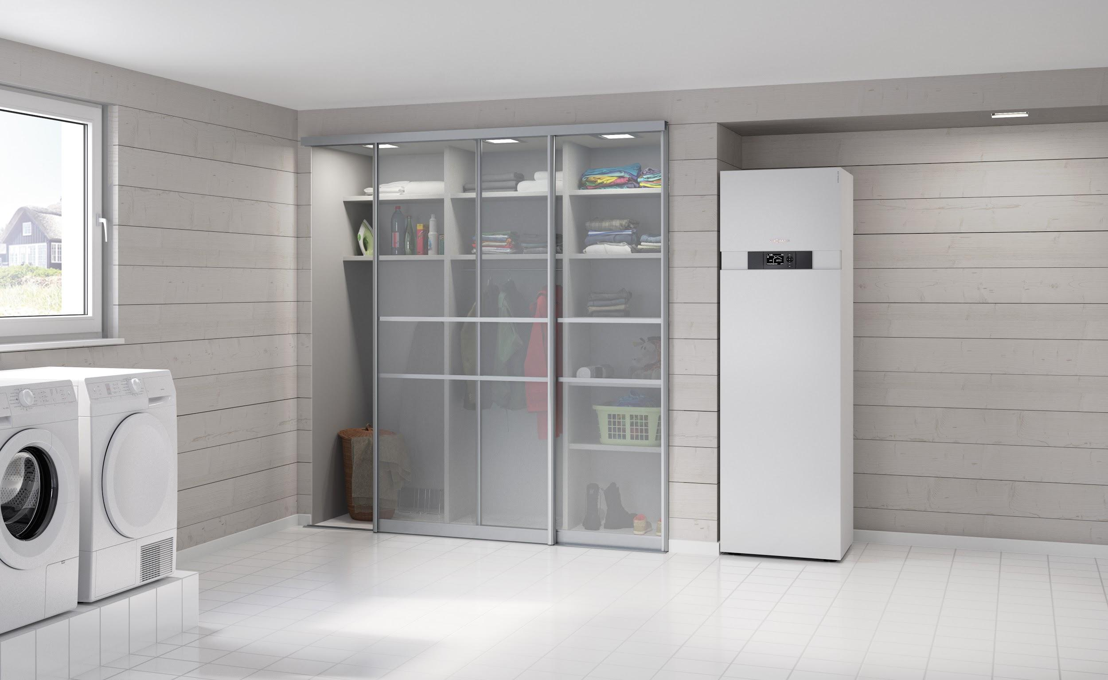
Image 1: Highly efficient, space-saving and particularly quiet – the new Vitocal 333-G and 222-G high-efficiency pumps from Viessmann also offer maximum hot water convenience.
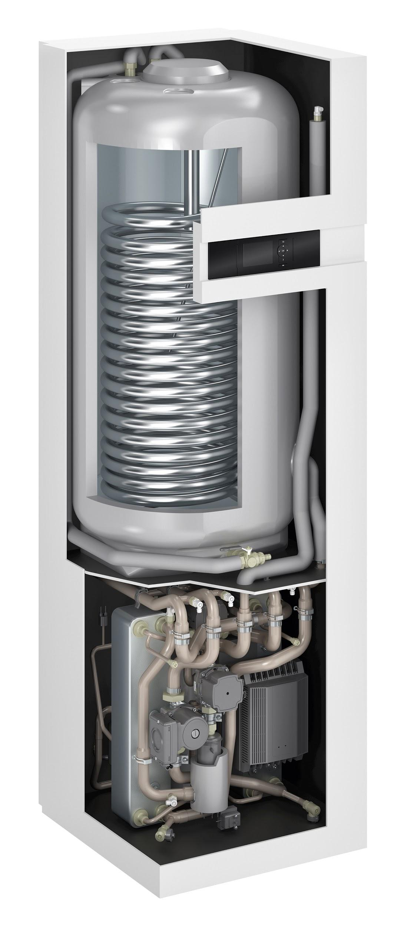
Image 2: Thanks to its modern inverter technology for output modulation, the Viessmann Vitocal 333-G compact pump is the most efficient solution for new builds.

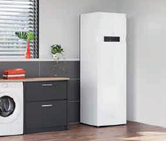
Image 3: The new Vitocal 222-G compact heat pump from Viessmann is a more affordably priced alternative to the 300 series compact heat pump.

March 2019

Viessmann Werke GmbH & Co. KG
35107 Allendorf (Eder)
Tel.: +49 (0)6452 702533
info-pr@viessmann.de
www.viessmann.de

