Save energy and protect the climate
New solutions offer quick and easy subsidy eligibility for automatic flow balancing

- Heating systems can be reliably optimized in the shortest possible time without the need for calculations, even in existing buildings
- Three simple steps to automatic flow balancing with the Vitoset Balance Card
- Automatic system optimization with ViCare radiator thermostats

Allendorf (Eder), 5/21/2021 – Automatic flow balancing is what finally makes a new heating system perfect. It ensures even distribution of heat in the house and significantly reduces heating and electricity costs, which prevents follow-up costs for a repeat service call. It would be a clear win, then, to make automatic flow balancing easier and faster, especially in modernization projects. That’s why Viessmann now offers the Vitoset Balance Card and ViCare radiator thermostats, two innovative solutions that enable specialist partners to optimize heating systems more quickly and easily than ever before.

Necessary to replace boilers as part of modernization

Both the German Building Energy Act (GEG) and Part C of the German Construction Contract Procedures (VOB/C) require automatic flow balancing in order to achieve an optimized overall system without uneven heat distribution and unnecessary energy
consumption. This protects both the environment and homeowners’ wallets. However, especially in older houses, pipe cross-sections and lengths are all too often not known, and determining them is time-consuming and cost-intensive – an investment homeowners often don’t want to make. With Vitoset Balance and the ViCare radiator thermostats, calculations for heat demand and the pipe network are no longer necessary.

The Vitoset Balance Card: Three simple steps to automatic flow balancing

The Vitoset Balance Card allows the appropriate settings of the valves to be established based on room size and building age. Automatic flow balancing ensures that the entire heating system, from boiler control and pump output to the system hydraulics, is perfectly matched for partial and full load operation. Uniform supply to the heating surfaces is ensured at all times.

The correct flow rate for the respective room size can be easily set on the radiator:

- Place the Balance Card with the notch on the valve.
- Turn the valve with the card and set the existing room size according to the building age.
- Finally, the sum of all valve settings in the individual rooms is transferred to the parameterization of the heating circuit pump—all done! The system does the rest on its own.

Automatic flow balancing with Vitoset Balance can be used for single- and two-family homes with radiator heating systems, a building age of 1978 to 2009 and a maximum living area of 300 sqm. The requirements are the installation of a new Viessmann heater with heat demand controlled circulation pump and Oventrop Q-Tech valves on the radiators.

Further information and a video with detailed explanations on how to use the Vitoset Balance Card are available at viessmann.de/vitosetbalance.

ViCare radiator thermostats: Automatic flow balancing

The installation of ViCare radiator thermostats enables fully automatic flow balancing. ViCare radiator thermostats can be connected to the heat generator via the new Viessmann electronics platform or by using a Vitoconnect interface. This gives users the ability to easily control their heating system via the ViCare app.

To carry out automatic flow balancing via the ViCare radiator thermostats, all existing thermostats must be replaced with the ViCare radiator thermostats. The connection to the heat generator or as a standalone system without a heat generator (Vitoconnect OPTO2 required) enables fully automatic flow balancing. Since no adjustable thermostatic valves are required, automatic flow balancing can also be completed very quickly during modernization. As soon as a set temperature is entered for each room in the ViCare app, the flow temperature is also automatically adjusted.

A maximum of 20 rooms with radiator heating systems can be integrated. The area of application is thus mainly single- and two-family homes. Further information can be found at
vicare.viessmann.de.

Single room control for individual warmth and comfort

ViCare radiator thermostats not only offer automatic flow balancing – they also have energy-saving open-window detection and can be controlled via smartphone. Using the free ViCare app, users can set an individual temperature for each room as well as individual time programs. In addition, the modular concept allows further components (e.g. climate sensors) to be added at a later date and used via the app. In the future, the ViCare app will also use location services on request and will be able to detect the distance to the heating system. If a defined distance is exceeded on the way to work or on a trip, the server sends a command to the heating controller to reduce the heat output – this reduces costs. When a homeowner returns, the heating system is started up again following the same principle, making sure the home is warm and comfortable at arrival.

Connection to Vitoguide

An automatic connection to Vitoguide will also be available shortly. This allows documents
required for subsidy applications to be pre-filled automatically with the stored data, making the process faster and simpler. The system also continuously and independently checks the operating status of the heating system and informs the specialist partner in the event of a fault.

Secure government subsidies

Both automatic flow balancing with Vitoset Balance and automatic balancing via ViCare radiator thermostats are certified by TÜV-Rheinland and can be supported by BAFA with up to 20 percent of the eligible costs. Viessmann FörderProfi (Subsidy Pro) will provide information and, if desired, take care of the application: www.foerder-profi.de.

Benefits for trade partners

- Quick and easy automatic flow balancing in modernization projects
- Certified and safe with the Vitoset Balance Card or ViCare radiator thermostats
- Secure high government subsidies for heating system optimization
- Optimized overall system of adjusted radiators, heating circuit pump and heat generator reduces heating costs and protects the climate
- High energy efficiency, evenly distributed heating of the radiators and no disturbing noises

Benefits for users

- Improved warmth and comfort due to coordinated overall system
- Reduction of heating costs by up to 10 percent through automatic flow balancing
- Optimal utilization of fuel value and resources
- Electricity consumption – e.g. for the heating circuit pump – is reduced
- Noise at the radiator is reduced or avoided
- Reducing CO2 emissions protects the climate

Images/captions
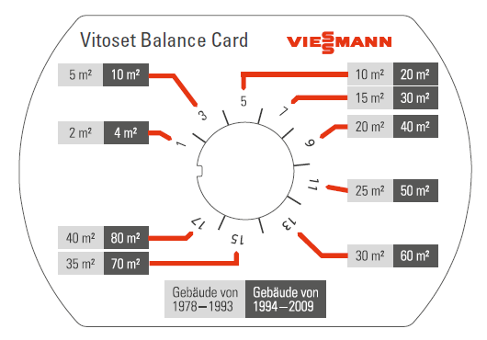
Image 1: Automatic flow balancing is what finally makes a new heating system perfect – with the innovative Vitoset Balance Card from Viessmann, this can now be done easily even in older houses and without having to make any calculations.

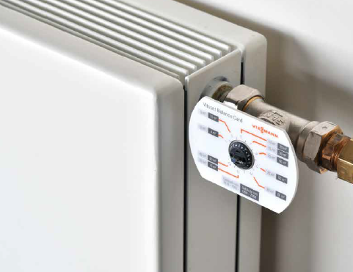
Image 2: In combination with Oventrop Q-Tech valves and a controlled heating circuit pump in a new Viessmann heat generator, the Vitoset Balance Card enables system optimization in just three simple steps.

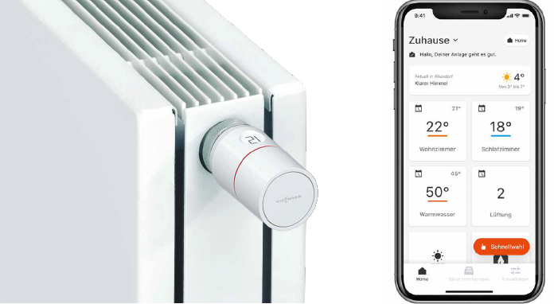
Image 3: ViCare radiator thermostats in conjunction with a Viessmann heating system and the ViCare app allow for automatic flow balancing.

Viessmann Climate Solutions SE
35107 Allendorf (Eder), Germany
Phone: +49 6452 702533
info-pr@viessmann.de
www.viessmann.de

