Photovoltaic systems after expiry of EEG subsidies
ViShare Energy Community doubles the value of solar power

- 6 cents per kilowatt hour with the ViShare electricity flat rate
- All-round worry-free solution: energy costs and yields agreed from the start
- Tariff calculator takes into account photovoltaic systems up to 30 kWp

Allendorf (Eder), 30.03.2021 – What to do if your more than 20-year-old photovoltaic system is no longer subsidised by the Renewable Energy Sources Act (EEG), but still generates solar power perfectly? After the reform of the EEG in December 2020, operators only receive the annual market value for solar energy. Last year, that was less than 2.5 cents per kilowatt hour. By contrast, for members of the ViShare Energy Community, electricity is worth more than twice as much: with the ViShare electricity flat rate tariff, they will receive 6 cents per kilowatt hour fed into the grid this year. The contractual partner for the ViShare tariffs is Energy Market Solutions GmbH (EMS), a subsidiary of the Viessmann Group.
All-round worry-free solution without hidden costs
With the ViShare electricity flat rate, community members receive an individual all-round worry-free solution with no hidden costs - there are no marketing flat rates or any other comparable costs. Switching to direct marketing of self-generated electricity is just as unnecessary as purchasing intelligent metering systems. With the ViShare electricity flat rate, operators of photovoltaic systems have their energy costs and yields agreed from the very beginning and receive all payment flows bundled in one tariff. The only prerequisite is the modernisation of the photovoltaic system with a Vitocharge VX3 electricity storage unit - a sensible investment for many in view of the current interest rate level as well as inflationary pressure.
Holistic system solution for maximum electricity consumption
For photovoltaic system operators who want to both maximise their electricity consumption and save on heating costs, supplying heat to their house with a heat pump is a particularly cost-effective solution. If the heat pump is operated with electricity from the photovoltaic system, it multiplies the energy yield from the solar panels by generating around four times as much heat for heating the building and hot water from one kilowatt hour of electricity and the heat from the surroundings. The electricity storage unit helps to ensure that the heat pump is operated as often as possible with the electricity from the operator's own roof. Even on hot summer days with intense solar radiation, the Vitocal heat pumps, which can be operated in reverse, can make good use of the large supply of electricity. In this case, the units are used for particularly cost-effective building cooling, which once again significantly increases the consumption of self-generated electricity and living comfort. The Viessmann GridBox combines the components into a holistic overall system and optimises the energy flows in the house.
Just a few steps to find out your individual ViShare contribution
The ViShare tariff calculator can be used to quickly and easily determine the individual energy costs for holistic energy systems with photovoltaic systems up to 30 kWp: vishare.viessmann.de/flatrate
ViShare: Community drives the energy transition
Climate protection and independence from conventional energy suppliers are good reasons to generate your own renewable energy and become a member of the ViShare Energy Community. Members supply themselves exclusively with 100 percent green electricity. This is regularly checked and certified by TÜV Nord.
ViShare members generate their own green electricity, for example with a photovoltaic system or an electricity-generating heating system. Surplus electricity either flows into an electricity storage unit for later consumption or is fed into the grid at a profit. Conversely, in the event of a member’s electricity deficit, they can access 100% green electricity from the grid.
Advantages for members
- Members are part of the ViShare Energy Community and receive cheap 100% green electricity.
- With ViShare, 100% green electricity is always available precisely when it is needed, even at peak consumption times
- Electricity and heat hand in hand - reliable energy technology meets reliable energy supply
- Energy by flat rate - an individually and flexibly adaptable flat rate without hidden costs with excess consumption buffer, yield guarantee and energy-saving bonus
- By taking out the flat rate, ViShare members enjoy the cost savings immediately after commissioning the system
- Full transparency of all energy flows through simple monitoring providing the basis for intelligent energy management

Images / Captions
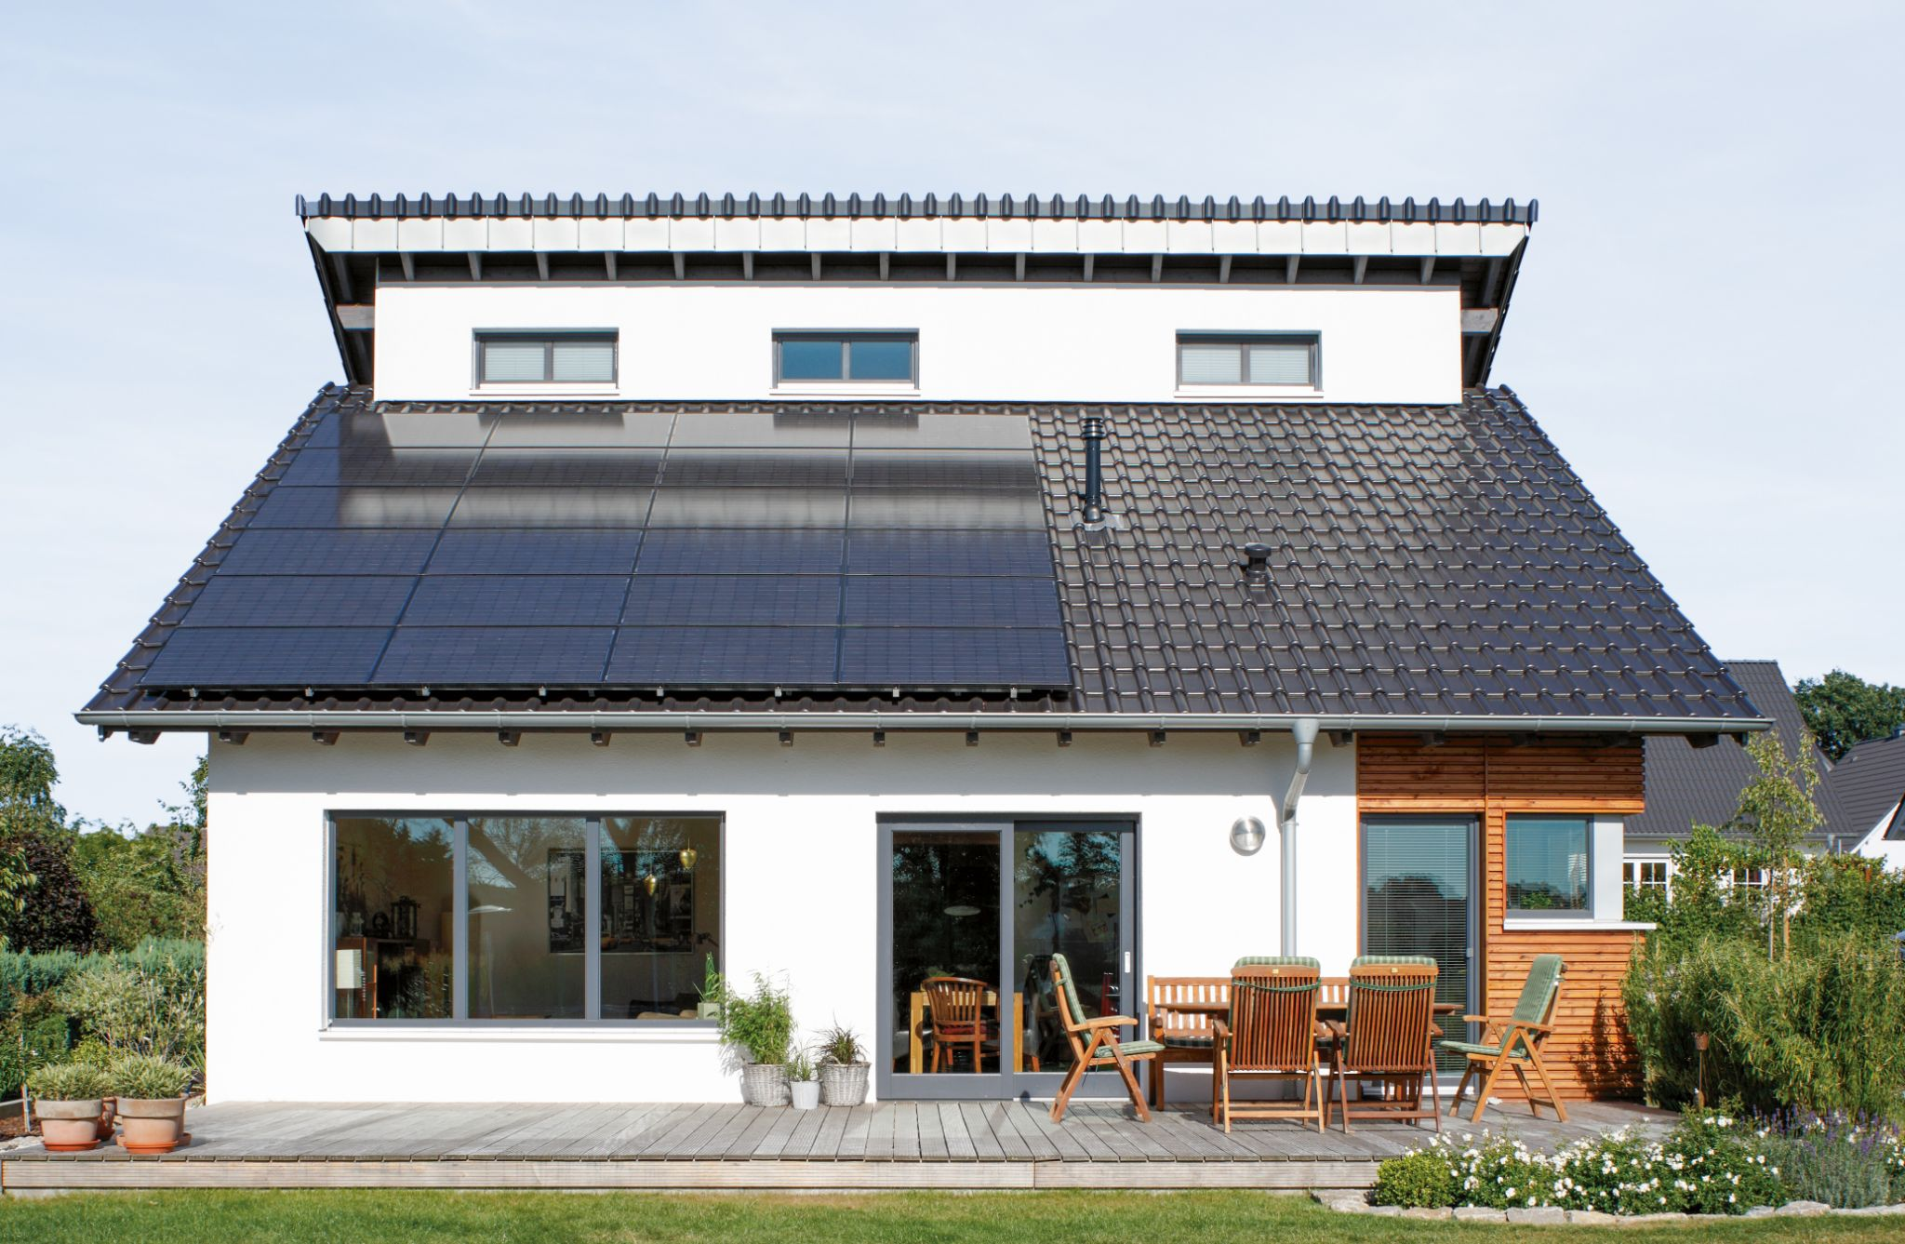
Image 1: Photovoltaic system operators who are no longer subsidised receive more than double the EEG compensation with the ViShare electricity flat rate. The contractual partner is Energy Market Solutions GmbH (EMS).

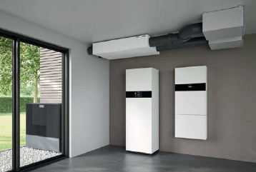
Image 2: For photovoltaic system operators who want to maximise their own electricity consumption and save on heating costs at the same time, supplying heat to their home with a heat pump is a particularly cost-effective solution. The image shows the new Vitocal 252-A heat pump with integral DHW cylinder, the wall mounted Vitocharge VX3 power cylinder and the new Vitoair FS domestic ventilation system.

About Viessmann
Viessmann is the leading provider of climate solutions for all living spaces. The ‘Integrated Viessmann Solutions Offering’ enables users to connect products and systems seamlessly via digital platforms and services for climate (heating, cooling, air quality) and refrigeration solutions. All solutions are based on renewable energy and maximum efficiency. All activities of the family company, founded in 1917, are based on its purpose. “We create living spaces for generations to come” – that is the responsibility of the global Viessmann family with 12,700 members.

Viessmann Climate Solutions SE
35107 Allendorf (Eder)
Telefon: +49 (0)6452 702533
info-pr@viessmann.de
www.viessmann.de

