Connectivity and platforms: Innovative solutions for the connected world
Connectivity and platforms are becoming an increasingly important part of Viessmann’s Integrated Solution Offering. By seamlessly networking energy systems with digital services, specialist partners can offer their customers new services, such as remote maintenance and remote parameterization of heating systems. Digital platforms, such as wibutler, also enable cross-trade smart home solutions.
The new products at a glance
- The new Viessmann Energy Management system makes energy flows in the home transparent and enables them to be used in a resource- and cost-saving way.
- The vendor-neutral wibutler Smart Home Platform now communicates with all other ViCare components: from the ViCare radiator thermostat to the ViCare climate sensor. In addition, the integration of the latest generation of Vitodens wall-mounted gas boilers has now been successfully completed.
- The new Vitocontrol 100-M is the central system control for monovalent and multivalent heating systems in municipal and commercial applications, as well as in large residential complexes.

Viessmann Energy Management for the efficient operation of all components
Conserving resources and saving costs by way of the energy-efficient, optimized operation of all electrical and thermodynamic-electrical energy systems in the home – this is the strength of the new Viessmann Energy Management, which is optionally integrated in the new electronics platform and can be made available to customers via the ViCare app without additional accessories. Aside from controlling components, the Energy Management groups connected devices such as Vitocal heat pumps, the Vitocharge VX3 electricity storage system and thermodynamic DHW cylinders together online to form an overall system. Users are thus provided with a functional system management concept for optimal operation. In this way, many system components in the home can be controlled in a resource-conserving and energy-efficient manner.
All energy flows at a glance
Viessmann Energy Management displays energy flows in the building in real time on a smartphone or tablet. This includes, among other things, values of self-generated electricity from the photovoltaic system, as well as self-consumed electricity, for example, for the operation of the heat pump. In particular, Viessmann Energy Management provides these functions for the Vitocharge VX3 electricity storage system, the heat pumps of the new Vitocal 25x-A series, as well as the heat pumps in existing buildings with Vitoconnect up until 2016.

Prepared today for tomorrow’s components
Energy Management is an interactive tool in the Viessmann product world. It follows the familiar solutions for commissioning and monitoring an energy system for specialist partners, as well as the same solution for visualization and control in the app environment for customers.
The charging of e-cars, taking into account weather data, the status of the vehicle battery and photovoltaic power generation according to user preferences, will be able to be optimized from the end of 2021 onwards. Users will be able to choose whether to use only self-generated electricity from the photovoltaic system or the fuel cell heating device, or to charge additionally with energy from the power grid.
Benefits for trade partners
- Commissioning via Vitoguide
- Recommendations for action to optimize the overall system
Benefits for users
- View and evaluation of historical data up to two years in the past
- Display of the current self-sufficiency rate within the system
- Clearly structured energy cockpit with power generation, storage and consumption in the household
- Photovoltaic surplus electricity management (photovoltaic heat pump optimization)
- Extensive energy report with analysis function
- Statistics on CO₂ emissions and CO₂ savings

GridBox 2.0: Intelligent control of wallbox for electric vehicles
Exploiting self-generated electricity and reducing the use of expensive mains current as far as possible – the Viessmann GridBox intelligently manages power generation, storage and consumption to increase the consumption of self-generated electricity. As the central platform for connecting the photovoltaic system, electricity storage system, electric heat generation and a charging station for an electric vehicle, it optimizes energy flows and ensures transparency. It also forms the basis for achieving the KfW 40 Plus standard and obtaining the associated subsidy of up to EUR 30,000 per residential unit.
Increasing consumption of self-generated electricity with new optimization functions
The GridBox’s new optimization functions for the photovoltaic system, electricity storage system, DHW generation and wallbox for electric vehicles now make it possible to increase the consumption of self-generated electricity even further. In addition, users can prioritize utilization of self-generated photovoltaic electricity via the dashboard. For instance, they can specify what to charge first with the solar power: the electricity storage system or the rechargeable batteries of the electric vehicle. Rules regarding vehicle charging can also be defined.
The GridBox can also use surplus electricity from solar to operate a modulating heater inside the DHW cylinder, thus preventing it from feeding into the public grid. Any electricity that isn’t required at that moment can thus be stored thermodynamically for subsequent use for bathing, showering or cooking.
An overview of all-electric heat generators at all times
The online dashboard visualizes all of the power generators and consumers connected to the GridBox, as well as the electricity storage system and wallbox. Users thus have quick access to a compact overview of daily trends, weather forecasts, weekly reports, CO₂ monitoring and tips to save energy. What’s new is the visualization of all-electric heat generators such as Vitoplanar infrared heating systems in the individual rooms.
New mygridbox app for convenient monitoring on the go
All of the functions of the GridBox Dashboard are now also available in the new mobile app for Android and iOS smartphones. Power generation, storage and consumption can thus also be conveniently monitored and managed on the go.
Simple installation
The GridBox is simply connected to the electricity and the router or a switch (switch/MAC bridge). Following the setup process, which only takes a few minutes, it automatically scans the household for connected devices.
Benefits for trade partners
- Comprehensive system solutions from a single source with perfectly matched components for electricity and heating
- Comprehensive online monitoring and optimization of the entire system consisting of photovoltaic system, electricity storage system, wallbox, heat pump or fuel cell heating device (optional) and other consumers in the building
Benefits for users
- Straightforward visualization of energy flows and optimization of wallbox, electricity storage system, photovoltaic system and household consumption
- Visualization of current output values, as well as the degree of self-sufficiency and energy mix
- Component of the Viessmann Energy Community
- Optional connection and visualization of the consumption and generation values of Viessmann heat pumps, fuel cell heating devices and direct electric heating systems
- Fast identification of defective or faulty devices, as well as potential for saving energy
- Detailed report function with energy balances on a daily, weekly, monthly and annual basis
- Reduced losses due to curtailment of the photovoltaic system
- Basis for achieving the KfW 40 Plus subsidy
- Online user interface for all internet browsers and mobile apps
- Online updates
- Supports all inverter types in the Viessmann product range
Delivery
The Viessmann GridBox 2.0 is already on the market.

wibutler: Cross-trade automation of living spaces
The wibutler is the smart home solution from Viessmann. Its particular strength is the manufacturer-independent platform for digital building services. The wibutler pro control and alarm center is the heart of the system. Thanks to common communication standards, the wibutler pro networks over 250 devices from more than 30 manufacturers today.
Through individually created automation rules, wibutler can increase living comfort, energy efficiency and security in the home. Everything is controlled conveniently from a smartphone or tablet. wibutler is equally suitable for new and existing buildings because the system supports both wireless and cable-based installations.
Compatible with ViCare components and the latest Vitodens generation.
The wibutler pro communicates with all ViCare components: from the ViCare radiator thermostat to the ViCare ZigBee Repeater and the ViCare climate sensor. In the future, this will even apply to the ViCare floor heating. In addition, the integration of the latest generation of Vitodens wall-mounted gas boilers has now been successfully completed – another milestone in expanding the compatibility of different Viessmann products. As a result, wibutler and ViCare connect all Viessmann appliances from boilers to compatible window contacts for optimum living comfort. The commissioning of all devices and configuration of the demand-driven individual room and the higher-level heating control are carried out intuitively using illustrated step-by-step instructions on a smartphone.
For fresh air in the home together with high energy efficiency, Vitovent home ventilation devices are also compatible with wibutler. Networking allows them to be controlled as a group or individually.
Energy flows made visible
With the integration of the Vitocharge VX3 electricity storage system (planned for Q3/2021), users have an overview of the energy flows via the wibutler app. This includes the charging status of the electricity storage system or the current consumption of self-generated electricity from the photovoltaic system.
Always up-to-date about constantly growing application possibilities
The wibutler.com website provides regular information about new products and the ever-growing range of applications. Interested specialist partners can find dates for basic training courses and electrical and HVAC advanced training courses, as well as online seminars on many different topics related to wibutler.
With the wibutler tradesman search, expert tradesmen in the vicinity can be found who offer their support for the installation of wibutler.
Numerous applications and references, as well as the offer of starter packages, facilitate the process of digital home automation.
Benefits for trade partners
- Quick installation and commissioning thanks to wireless communication between components
- Programming skills are not required
- All necessary installation steps easily and conveniently via the wibutler app.
- Expansion of the product and service range
- Modular and expandable for follow-up business
- Technical support and professional training courses provided by wibutler
Benefits for users
- wibutler pro brings together and optimizes the control of individual rooms, as well as heat distribution and generation
- Heating controlled in accordance with requirements for high energy-saving potential
- Simple control of room temperatures via smartphone or tablet
- Individual weekly plans via wibutler app
- Malfunctions reported directly to the user’s smartphone via the app
- Compatible products can be added easily and over time
Compatible Viessmann heating systems
- Wall-mounted gas boilers:
  - Vitodens 2xx with electronics platform
  - Vitodens 3xx with electronics platform
  - Vitodens 2xx with Vitotronic platform from 2004 onwards
  - Vitodens 3xx with Vitotronic platform from 2004 onwards
- Heat pumps:
  - Vitocal 2xx with Vitotronic platform from 2010
  - Vitocal 3xx with Vitotronic platform from 2010

Vitocontrol 100-M: New multivalent system control unit for municipal and commercial systems
Vitocontrol 100-M is a modular system control unit with an operator-oriented, graphical user interface for monovalent or multivalent heating systems in municipal and commercial applications, as well as in large residential complexes. It takes into account the requirements stipulating the careful use of resources and the system’s energy-efficient operating mode with well-thought-out control strategies.
Simple initial setup through diagram-specific commissioning wizards
The Vitocontrol 100-M supports a wide range of predefined system examples. Each of these is tested in the system network, ensuring the smooth operation of the system. For commissioning, the system configuration is transferred to the control unit as a file. Subsequently, the schematic-specific commissioning wizard guides the user through the initial setup. Based on the configuration file, a delivery state adapted to the system is generated – this means that the control system is immediately ready for use.
Integration into the building management system
The integration of the Vitocontrol into a building management system is another plus point for the multivalent control unit: This enables the monitoring and control of the heat generators and system components connected to the Vitocontrol 100-M, for example, from a central control room. External control and retrieval of important values are possible via BACnet IP, Modbus TCP/IP (accessories required in each case) or via hardware contacts.
Remote diagnostics via internet
“Remote diagnostics access” allows the Vitocontrol 100-M control panel to be accessed via the internet and provides all operating options via a secure connection (accessories required). This includes the service level for the logged-in user. The optionally available accessories also help to reduce costs, as on-site service calls can be avoided. Software updates are also uploaded via this method without having to be present in the heating center.
Compatibility with Vitoscada
In addition, the Vitocontrol 100-M system controls are prepared for use with the Vitoscada digital service.
Benefits for trade partners
- Simple implementation of monovalent or multivalent systems based on system examples
- Fast commissioning via configuration file and commissioning wizards for standardized applications
- Compact wall-mounting housing (width x height x depth: 600 x 400 x 210 mm) for easy installation – even in confined spaces
- Convenient parameterization and system optimization via the color touch display
- Support of Vitotronic 200-H for integrating additional heating circuits and auxiliary buildings
- Connection of up to 5 M-Bus meters (accessories)
- Compatible with common BACnet & ModBus BMS interfaces (accessories required), as well as hardware contacts for external setpoint specification
- Operation of the system also possible without consumer circuits – virtual heating circuit controlled by atmospheric conditions for the formation of the system setpoint or adjustable constant system setpoint
Benefits for users
- Quick system overview by displaying the system diagram with status information on the seven-inch color touch display
- Intuitive operating concept allows easy access to information of all system components
- Convenient operation and individual display of operating data – optionally also via remote access
- Evaluation of system behavior via pre-deﬁned trend diagrams
- Central point of contact for evaluating and optimizing the operating behavior of the complete heating system.
- Email notification of messages from the overall heating system (messages from connected Vitotronic in plain text, messages from Vitobloc in plain text, pumps, pressure maintenance station, lifting units)

Further information
Further information on the subject of connectivity and platforms is available at www.viessmann.live.

Images/captions

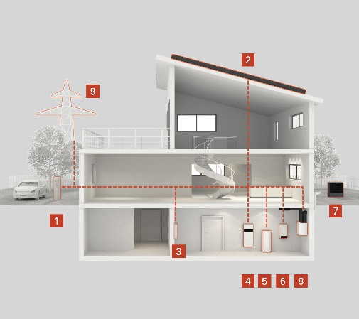
Image 1: Viessmann Energy Management: By networking Viessmann products with a new electronics platform, a building is transformed into an intelligent entity and can be controlled in a way that conserves resources while saving costs (1 Electric charging station, 2 Vitovolt photovoltaic system, 3 Grid connection, 4 Vitocharge VX3 electricity storage system, 5 Vitocell DHW cylinder, 6 Vitocal split air/water heat pump, 7 Vitocal heat pump external unit, 8 Vitovent home ventilation system, 9 ViShare from Energy Market Solutions GmbH, operator and contractual partner in the ViShare Energy Community).

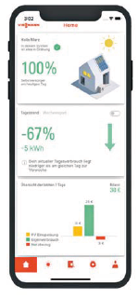
Image 2: All GridBox Dashboard functions are also available via the new mygridbox mobile app for Android and iOS smartphones.

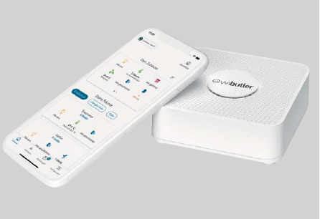
Image 3: wibutler pro communicates with all ViCare components: from the ViCare radiator thermostat, to the ViCare ZigBee Repeater, to the ViCare climate sensor. In addition, the integration of the latest generation of Vitodens wall-mounted gas boilers has now been successfully completed.

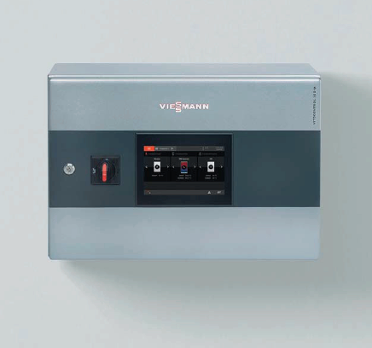
Image 4: Vitocontrol 100-M is a modular Viessmann system control unit with an operator-oriented, graphical user interface for monovalent or multivalent heating systems in municipal and commercial applications, as well as in large residential complexes.

March 2021

Viessmann Climate Solutions SE
35107 Allendorf (Eder)
Phone: +49 (0)6452 702533
info-pr@viessmann.de
www.viessmann.de

