Vitodens 300 series: Easy to install, operate and maintain
The next generation of Viessmann wall-mounted gas-fired units – developed in collaboration with specialist trade partners

Securing an utterly reliable and highly efficient heating and hot water supply for your own home is the top priority for the owners of houses and apartments. At the same time, operating these systems should be as simple and convenient as possible. Anyone looking for a new heating system need look no further than the innovative gas condensing boilers in the new Vitodens 300 series – available in both wall-mounted and compact versions. Never before have gas condensing boilers been so easy to install, operate and maintain. What’s more, the next generation of Viessmann wall-mounted gas-fired units also features a sleek design.

Award-winning design: Beautifully simple – simply beautiful
The new gas condensing boilers feature a high-quality, forward-looking design:
- Vitodens 300-W, the space-saving wall-mounted unit,
- Vitodens 333-F, the compact unit with integrated 100-liter stainless steel cylinder, and
- the Vitodens 343-F energy center, with 170-liter solar cylinder for immediate or subsequent combination with Vitosol solar collectors.
The units’ new matt white powder coating, Vitopearlwhite, is unique to the market. In combination with the attractive housing design and the ultra-flat front panel, the heat generators blend harmoniously into any home environment. The enhanced sheet thickness also provides extra stability. The Vitodens 300-W wall-mounted unit has received the Design Plus Award and the IF Award in recognition of its innovative design.

Height-adjustable color touch display for maximum ease of operation
Bending into awkward positions to operate wall-mounted gas condensing boilers – perhaps because they were installed in a cramped space with a low ceiling – is now a thing of the past. The position of the display can be moved upward in just a few simple movements. This means that the optimal ergonomic operating height can be quickly set in all installation situations.
The 7" color touch display is highly intuitive to operate. The colored graphics in the energy cockpit provide a concise overview of consumption figures and solar heat yields. The display’s light guide – a fluorescent strip of lights across the width of the device – shows the homeowner at a glance whether their heat generator is operating correctly.
- The light guide illuminates as soon as the heat generator is switched on.
- In stand-by mode, the light guide slowly pulsates.
- The light band acknowledges a new setting being applied via the touchscreen or a smartphone by flashing.
- If an error is detected, the light guide flashes continuously.

Integrated WLAN for convenience and safety of the highest order
The technological basis of the color touch display is the new modular electronic platform. It features an integrated WLAN as standard and facilitates networked digital communication between the heat generator, the homeowner and the specialist partner on an ongoing basis. The homeowner can control their heating system with ease and at any time using the ViCare app; if they wish, they can allow a specialist company of their choice to use the Vitoguide digital service center to monitor the system. With Vitoguide, the specialist partner can identify maintenance requirements or potential faults at an early stage, make parameter adjustments online and, if all else fails, intervene before the apartment loses heat. This ensures safety and convenience of the highest order. Another advantage is that Viessmann extends the warranty for all new heat generators for which this feature is activated from two to five years.

Heating with an environmental conscience
The newly developed MatriX Plus burner simultaneously ensures maximum reliability and maximum efficiency in the new product generation. With a modulation range of 1:17 and optimal flame stability, it precisely adjusts heat generation according to current requirements. The number of burner start-ups (cycles) is thereby reduced to a minimum. This ensures maximum efficiency (standard utilization rate up to 98% (H_{s})), particularly low fuel consumption, and a reduction of NOx emissions of up to 40% compared with previous models – easing your environmental conscience. The heat generated by the MatriX Plus burner is transferred via the proven rust-free stainless steel radial heat exchanger into the heating system.

Reliable operation even in the case of fluctuating gas quality thanks to Lambda Pro Plus combustion control
No matter whether the gas type changes, its quality fluctuates, or the operating conditions vary, the Lambda Pro Plus automatic combustion control in Vitodens gas condensing boilers ensures reliable and clean operation at all times with maximum efficiency. With Lambda Pro Plus, users also enjoy a cost benefit: regular chimney sweep inspections are only required once every three years – as opposed to every two years for conventional devices.
Lambda Pro Plus also saves the adjustment work required to install conventional gas-fired boilers. The combustion control detects the gas type and automatically adjusts the Vitodens unit to suit. Its height and exhaust line length adaption adjusts the heat generator to the exhaust gas line’s resistance and its elevation.

Simple installation and commissioning using the ViStart app
In addition, the new generation of gas-fired devices also make the day-to-day work of specialist partners easier in many respects. Thanks to the height-adjustable display, challenging tasks such as commissioning devices in inconvenient locations are now a thing of the past. The sophisticated commissioning assistant guides installers through the initial commissioning process in just a few steps; alternatively, the ViStart app is available for use on smartphones and tablets.
ViStart enables intuitive commissioning. Once the device’s integrated WiFi access point has been activated, the app automatically establishes a direct connection to the heat generator and guides the specialist partner through the entire process. No Internet interface is required as the app communicates with the heat generator control directly via its integrated WLAN interface.

Easy to maintain – around 50 % fewer spare parts
Maintenance has been made as easy as possible. Thanks to the modular construction used in the new generation of devices and the range of accessories available, the units not only require 50 % fewer spare parts but also form part of a far more clearly structured product range. For instance, the new MatriX Plus burner only requires one burner assembly, one ignition electrode and one burner seal for all output levels (1.9 kW to 32 kW). Its predecessor required specialist partners to stock three burner assemblies and three different electrodes due to varying dimensions. Specialist companies benefit as the stock of universal spare parts is reduced, thereby saving costs.

Developed in conjunction with specialist trade partners
In addition, the new generation of Viessmann wall-mounted gas-fired units is so closely tailored to customers’ requirements because it was developed in collaboration with specialist trade partners. Ultimately, nobody is better qualified to help develop new solutions than the specialists who will go on to install them and hand them over to users.

Advantages for trade partners
- Low cycling frequency, even when little heat is drawn off
- High durability and efficiency thanks to stainless steel radial heat exchangers
- MatriX Plus burners with longer service life thanks to stainless steel MatriX perforation
- Lower cost due to fewer spare parts and reduced complexity
- Lambda Pro Plus automatic combustion control for all gas types
- Quiet operation thanks to low fan speed
- Highly convenient to operate using the 7" height-adjustable color display or the ViCare app
- Simple commissioning using the commissioning assistant or the ViStart app
- Integrated WLAN interface for Internet connection

Advantages for homeowners
- Particularly straightforward, intuitive operation and integrated WLAN interface
- High operational reliability thanks to Lambda Pro Plus automatic combustion control
- Enhanced efficiency and up to 40 % less nitrous gas emissions thanks to the new MatriX Plus burner
- Energy cockpit shows energy consumption and solar yields
- Check at a glance whether unit is operating correctly using fluorescent light guide
- High degree of hot water convenience in a compact space thanks to the 100-liter stainless steel cylinder (Vitodens 333-F) or 170-liter solar cylinder (Vitodens 343-F)

Technical data
Output: 1.9 – 32.0 kW (Vitodens 300-W, 333-F) or
1.9 – 19.0 kW (Vitodens 343-F)
Standard utilization rate: 98 % (Hs)
Modulation range: 1:17 (Vitodens 300-W, 333-F) or
1:10 (Vitodens 343-F)
Energy efficiency category: A

Delivery date
The new generation of the Vitodens 300 series is available now.

Images / captions

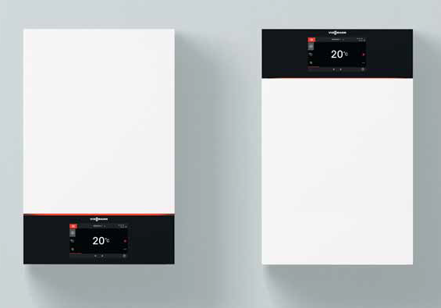
Image 1: The new generation of Vitodens gas condensing boilers from Viessmann features a high-quality, forward-looking design. The Vitodens 300-W’s 7" color touch display can be moved upward with just two simple movements.

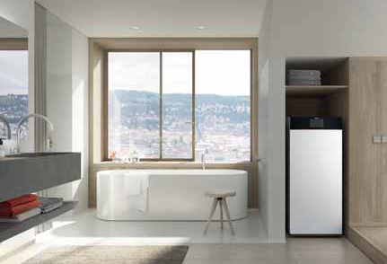
Image 2: The Viessmann Vitodens 333-F compact gas condensing boiler features a 100-liter drinking water cylinder for a high degree of hot water convenience.

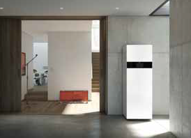
Image 3: The new, compact Viessmann Vitodens 343-F is fitted with a 170-liter solar cylinder for either immediate or subsequent connection with solar collectors.

March 2019

Viessmann Werke GmbH & Co. KG
35107 Allendorf (Eder)
Tel.: +49 (0)6452 702533
info-pr@viessmann.de
www.viessmann.de

