Vitodens: The next generation in the 200 segment
More efficiency, fewer emissions
Homeowners who want to do something good for the climate at a manageable cost while also saving on energy costs are choosing the new Vitodens 200 generation. Numerous new features now make the devices even more appealing and easy to use for trade partners and users. This included several suggested improvements from the trade partners being developed for the Vitodens family relaunch and implemented this year.
New displays, additional functions
Despite the fact that most of the newly installed boilers are now connected and are easy to control with the ViCare app, many trade partners and users still prefer to use the conventional operation directly on the heat generator. A 7-inch grayscale touch display is now also available for the Vitodens 200 series as an alternative to the 3.5-inch standard display for exactly this purpose.
Functions such as the adjustment of high-efficiency pumps for continuous operation have been simplified to keep operating noise as low as possible and reduce energy costs. However, the commissioning of devices on the display or by using the ViStart app has also been improved.
Sustainable with H2-ready certificate
Today, up to 20 percent of green hydrogen is already being added to natural gas in order to reduce CO₂ emissions as quickly as possible and combat climate change. The new Vitodens 200 generation is already certified for operation with this volume of hydrogen and could even easily convert up to 30 percent into heat in an efficient and climate-friendly manner.
The Lambda Pro Plus combustion control then adjusts the condensing boiler automatically to the fuel provided. This also applies to biomethane or liquid gas.
The right solution for every requirement
With outputs of 2.5 to 32 kilowatts (Vitodens 242-F up to 19 kilowatts), the new gas condensing boilers of the Vitodens 200 series are equally suitable for new or existing buildings:
- Vitodens 200-W, the space-saving wall-mounted boiler that can serve as a system or combi boiler,
- the wall-mounted compact boiler Vitodens 222-W, with an integrated stainless-steel primary cylinder with a capacity of 46 liters for a high level of hot water convenience,
- the floorstanding compact boiler Vitodens 222-F, which can optionally be equipped with an integrated 100-liter primary cylinder or with a 130-liter coiled tube DHW cylinder for areas with hard drinking water and
- the compact energy center Vitodens 242-F with a 170-liter solar cylinder and all relevant components for connection with solar collectors.
These new devices provide homeowners and specialist partners with genuine value relative to traditional heat generators, with benefits such as simple, intuitive operation through a height-adjustable display, innovative digital control based on the new electronic platform with integrated WLAN for convenient management through the ViCare app and simple commissioning with the new Vitoguide, increased security from the option of remote maintenance by a selected specialist partner with Vitoguide and, last but not least, a highly efficient, environmentally friendly and reliable gas condensing technology.
Low emissions and a consistently high degree of efficiency
The MatriX-Plus burner in the new Vitodens 200 generation ensures maximum efficiency and reliability. With a modulation range of up to 1:13 (Vitodens 242-F 1:8) with maximum flame stability, it continuously adjusts heat generation according to current needs. This serves to reduce the cycling of the burner to a minimum, achieving a high standard utilization rate of up to 98 percent (Hs). The proven stainless-steel radial heat exchanger made from rust-free stainless steel transfers the heat generated by the MatriX-Plus burner to the heating system.
Simple commissioning via app and commissioning assistant
A number of additional features of the new Vitodens 200 series substantially simplify the commissioning and maintenance of the devices. The commissioning assistant integrated into the new electronic platform takes the installer through the entire process in just a few steps. This not only ensures a simple and error-free process, but also saves a considerable amount of time.
The start-up procedure can also be carried out just as quickly and smoothly but even more conveniently via the ViStart app or the new Vitoguide which is now also available for mobile use. Following activation of the Wi-Fi access point integrated into the device, the app automatically forms a direct connection with the heat generator and guides the specialist partner through the entire process. No internet interface is necessary, since the connection with the control unit takes place directly through the heat generator’s WLAN interface.
Benefits for trade partners
- Quick and simple commissioning with the new electronic platform
- Improved service and troubleshooting with the new electronic platform
- Uniform digital platform with display, ViCare and Vitoguide for all devices
- Wide range of products for single- and two-family homes
- Available as 7-inch grayscale touch display or 3.5-inch display
- The heat generation is adapted precisely to accommodate the current heat demand with a large modulation range
- Reduced number of spare parts through module strategy simplifies service
- Sustainable thanks to 20 percent H2-ready
- Low susceptibility through newly developed heat cell with a MatriX-Plus burner and Lambda Pro Plus combustion control
Benefits for users
- High efficiency for lower operating costs
- Long lifespan with stainless steel heat exchanger
- Great system convenience and high system efficiency with optional single room control system
- Expandable with coordinated Viessmann system components (e.g. Vitocal, Vitovent, Vitosol)
- Compatible with digital platforms (Apple Home Kit, Alexa, Google)
- Simple operation on the device or with the ViCare app
- Effective monitoring from specialist partners with Vitoguide (optional)
- Sustainable with 20 percent H2-ready (reduced CO₂ emissions)
- Appealing design for living room installation
- Made in Germany
- 5-Year guarantee on connected systems
Technical specifications
- Standard utilization rate: 98 percent (Hs)
- Modulation range up to 1:13
- Output: 2.5 to 32 kW
- Dimensions (length x width x height):
  - Vitodens 200-W: 360 x 450 x 700 mm
  - Vitodens 222-W: 480 x 600 x 950 mm
- Weight: 33 kg (Vitodens 200-W, heater)
34 kg (Vitodens 200-W, combination device)
67.8 kg (Vitodens 222-W)
- Energy efficiency category: A
Availability on the market
The next generation of the Vitodens 200 series has already been launched on the market.

Further information
Further detailed information on the new Vitodens gas condensing boilers can be found on the virtual platform www.viessmann.live

Images/captions
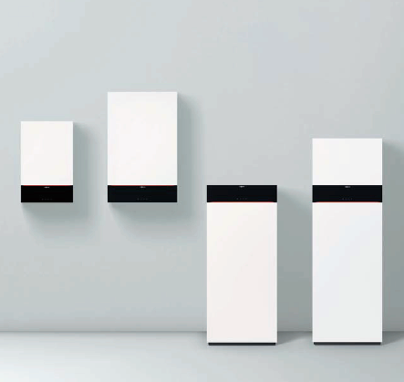
Image 1: The new generation of Vitodens 200 gas condensing boilers from Viessmann is already certified for operation with up to 20 percent hydrogen in natural gas and is therefore extremely sustainable.

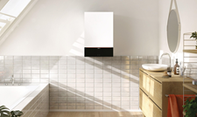
Image 2: With output levels of 2.5 to 32 kilowatts, the new Vitodens 200-W wall-mounted gas condensing boilers from Viessmann are equally suitable for new and existing buildings.

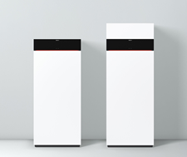
Image 3: The Vitodens 222-F compact gas condensing boiler is optionally available with an integrated 100-liter primary cylinder (left) or a 130-liter coiled tube DHW cylinder (right).

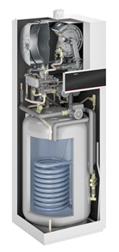

Image 4: The new Viessmann Vitodens 242-F compact boiler is prepared for connection to solar collectors thanks to a 170-liter enameled solar cylinder and all other relevant components.

March 2021

Viessmann Climate Solutions SE
35107 Allendorf (Eder)
Phone: +49 (0)6452 702533
info-pr@viessmann.de
www.viessmann.de

