Sustainable for digital services:
New electronics platform for wall-mounted gas-fired units and fuel cells

Homeowners today expect to be able to operate their heating system as easily as possible by smartphone. After all, who wants to spend an unnecessarily long time at the heat generator, e.g. adjusting a time program to suit their personal needs. Similarly, the work of installers also becomes far easier if they always find the same controls across different devices – regardless of whether it's a gas condensing boiler from the new Vitodens generation or a Vitovalor fuel cell heating system, for example. Viessmann has therefore developed an innovative electronics platform that sets new standards in easy and convenient operation. Modular construction, start-up-procedure by app and detailed fault messages simplify planning, installation and service.

Designed for extensive digital services
The new electronics platform is used in the gas condensing boilers from the new Vitodens generation and in the Vitovalor PT2 and PA2 fuel cell heating devices. It enables end-to-end networked digital communication between the device and homeowner or specialist partner – initially for gas condensing boilers and soon also for fuel cell systems.
Using the standard Wi-Fi interface, homeowners can configure the personal time programs already mentioned and numerous other settings easily and conveniently with the free ViCare app, for example. After activation by their customers, specialist partners have the option of comprehensive remote diagnosis via the Vitoguide digital service center, can alter parameters online if necessary and can identify possible faults and maintenance requirements early on. With an eye to the future, the electronics platform is already designed for extensive digital services, benefiting specialist partners and homeowners alike. This ensures safe, cost-effective and environmentally friendly operation at all times.

Convenient start-up-procedure by ViStart app
One of the digital services is the new ViStart app. It assists installers during the initial start-up by guiding them through the entire procedure in a few easy steps, meaning this task can be conveniently completed using a smartphone or tablet. An Internet connection or access to the customer's home network is not required for this. The integrated Wi-Fi acts as the interface to the device. Annoying cables that used to be necessary are no longer needed and the installer does not have to be so close to the device.
Alternatively, the upgraded start-up assistant built into the electronics platform can be used instead of the app. There's no need to refer to a printed manual or checklist. Once every step has been completed, the start-up-procedure is finished.

Integrated pressure sensor visible online, too
The electronic platform in devices from the new Vitodens 300 generation is equipped with a digital pressure sensor. The system pressure is thus visible on the heat generator's display, as well as in the ViCare app and Vitoguide. This simplifies remote system diagnosis.

Fast troubleshooting thanks to detailed fault messages in plain text
Other advantages of the new electronics platform: fault messages are now far more detailed than before and deliver precise information about possible causes in plain text. Combined faults are split into separate messages. What is more, identical messages are issued for the same cause on all devices with the new platform, making troubleshooting much easier and faster. The once time-consuming search in documents to understand the meaning of a message is no longer necessary.

Significantly fewer spare parts
The modular construction of the electronics platform requires significantly fewer components than conventional control engineering. This ultimately means significantly fewer spare parts and lower complexity in the product range. This simplifies planning, installation and service.

Comprehensive accessories
Numerous expansion modules are available for the new electronics platform, including for controlling and regulating one or two mixed heating circuit(s) and for solar DHW generation. The modules are connected to the device's control unit via the newly developed – especially fast and secure – PlusBus.
In addition to using the ViCare app to operate the devices with the new electronics platform, they can be operated with two new optional remote controls, too. Vitotrol 300-E communicates with the heat generator by radio, i.e. wirelessly. The modern casing contains a round color display with illumination that switches on automatically when it is approached. Vitotrol 200-E communicates with the heat generator via cable and has a monochrome display.

Solution provider for the entire home
The new digital services also reflect the shift at Viessmann – a shift away from a pure heating manufacturer toward a solution provider for the entire home. The main driver here is the new integrated Viessmann solution offering, which seamlessly links products and systems, as well as all the digital services.

Advantages for trade partners
- Improved fault diagnosis with uniform fault messages in plain text
- New and secure connection of expansion modules with PlusBus
- Variety of spare parts reduced thanks to uniform modules
- Wireless local interface for app/heat generator
- Easy start-up-procedure using the ViStart app (Vitodens)
- Digital pressure sensor for display in Vitoguide (Vitodens)

Advantages for homeowners
- Easy and intuitive operation
- Energy cockpit with clear graphic display of consumption and solar heat yields (Vitodens)
- Integrated Wi-Fi interface for remote control with ViCare app and system monitoring by the specialist company via Vitoguide

Scheduled delivery date
The new electronics platform is already available in the Vitovalor PT2 fuel cell heating device and will be available in the Vitovalor PA2 fuel cell module and in the gas condensing boilers from the new Vitodens generation from April 2019.

Figures and captions

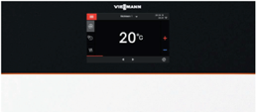
Figure 1: The new Viessmann electronics platform's 7" color touch display has an appealing glass look and an integrated light guide. The fluorescent LED strip informs the homeowner about the current operating state in real time.

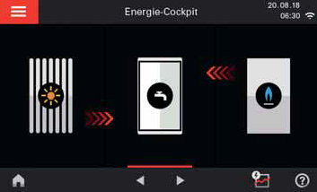
Figure 2: The energy cockpit in Viessmann's new electronics platform displays energy flows graphically.

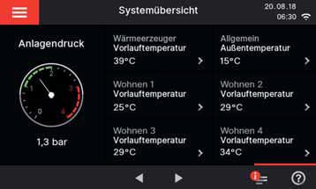
Figure 3: The digital pressure sensor in the new Vitodens gas condensing boilers from Viessmann makes it possible to read the system pressure both on the display in the heat generator and via the ViCare app.

Figure 4: In addition to using the ViCare app to operate the devices with the new electronics platform, they can be operated with the new optional Vitotrol 300-E wireless remote control, too, for example.

March 2019

Viessmann Werke GmbH & Co. KG
D-35107 Allendorf (Eder)
Phone: +49 (0) 6452 702533
info-pr@viessmann.de
www.viessmann.de

