ViStart: The new app for professionals
The fastest, simplest and safest way for Viessmann partners to commission heat generators

Time is money – and the next customer is already waiting for the engineer to visit. To ensure new heat generators can be commissioned quickly and without any problems, Viessmann has developed a new tool for trade professionals: the innovative ViStart app. It makes work easier for specialist installers and reduces the time before handover to the customer.
Commissioning in four steps
Once the heat generator has been installed, using a smartphone or tablet (iOS or Android) and the ViStart app makes commissioning light work for Viessmann partners. In just a few steps, the app guides the installer through the entire commissioning procedure:
- Select the heat generator to be commissioned from the list; the app then automatically establishes a direct connection to the device. The integrated WiFi access point means that no Internet connection is required.
- After entering the network name and a password, the clearly arranged dashboard appears. The heat generator’s serial number appears for checking purposes and can be confirmed by tapping “Next”.
- The app then allows the installer to inspect and set all parameters, such as system pressure, heating curves, the name of the heating circuit and timer programs.
- The device starts up. An acceptance report containing all settings can then be generated to complete commissioning. This can also be mailed to customers for their own documentation.
Sensors and meters in the device ensure that all steps are carried out properly, in full and also in the correct order.
Added safety for all customers
Once commissioning is complete – and providing the homeowner would like the convenience of operating their system via the ViCare app – an Internet connection can be activated using the touchscreen on the heat generator. The ViCare app then establishes the connection to the existing WLAN. Homeowners can now access their systems wherever they are using their smartphone.
Furthermore, thanks to the Vitoguide digital service center, specialist companies can access all key system data at any time. This makes it possible to optimize a system from any computer – another way to save time and costs. All this service requires is a one-time activation by the customer via the ViCare app. As a further benefit, in addition to ensuring a high degree of safety for their system, homeowners also enjoy a warranty extension from two years to five.

ViStart is available for download, free of charge
The new ViStart app is available to download for free from the Apple App Store and the Google Play Store and can currently be used to commission all gas condensing boilers in the new Vitodens generation. The app will be further developed and expanded to include all new heat generators launched with the new electronic platform.

Advantages for trade partners
- Simple, fast and faultless commissioning through a fully guided process
- Maximum flexibility as no Internet connection or Optolink interface is required
- All parameters are queried in turn and in the correct order
- Acceptance report containing all settings
Advantages for homeowners
- New systems are made ready for operation faster than with conventional commissioning
- Warranty can be extended up to five years by connecting your heating system

Delivery date
The new ViStart app is available now.

Images / captions
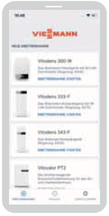
Image 1: The new ViStart app from Viessmann, which makes commissioning fast and simple, can be used for gas condensing boilers from the new 300 series with the new electronic platform.

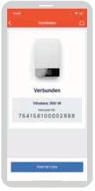
Image 2: The Viessman ViStart app makes commissioning easier for installers and reduces the time before handover to the customer.

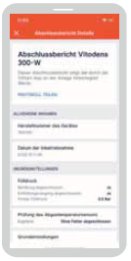
Image 3: With the ViStart app, an acceptance report can be generated containing all settings to complete commissioning.

March 2019

Viessmann Werke GmbH & Co. KG
35107 Allendorf (Eder)
Tel.: +49 (0)6452 702533
info-pr@viessmann.de
www.viessmann.de

