**Battling the Coronavirus: new ventilation systems for single-family homes, apartments, schools and medical practices**

*Effective protection against infection and fresh air for pleasant room conditions*

Since the outbreak of the global coronavirus pandemic, awareness has grown considerably that good ventilation systems play a decisive role in health and well-being. Fresh, clean and, above all, germ-free ambient air is more important today than ever before. At the same time, it prevents mold growth and protects building structures. During the cold months of the year, heat recovery can also save heating costs and protect the climate. Viessmann creates and maintains living spaces for future generations – with innovative air purification and ventilation systems.

**The new products at a glance**

* Vitovent 200-P was developed primarily for use in schools, seminar rooms and nurseries. The hybrid ventilation solution brings fresh outside air into classrooms while also purifying the ambient air of aerosols and fine dust.
* The Vitovent 300-W home ventilation system with an air volume flow rate of 225 m3/h complements the proven systems with 325 and 400 m3/h.
* With its low overall height of 245 millimeters and a maximum air volume flow rate of 300 m3/h, the new Vitoair FS home ventilation system is not only the flattest but also the most compact unit in its class.
* Even complex air distribution systems can be installed in a short time – the new Click and Go air distribution system for centralized home ventilation systems is impressive thanks to its simple, quick and safe installation.

**Vitovent 200-P: Innovative ventilation solution for schools**

It has long been known that without ventilation systems the air quality in schools and other rooms where people congregate is inadequate. This has negative consequences for health, well-being and learning efficiency. The coronavirus pandemic has sharply increased awareness of this fact. In order to enable essential work in public institutions and, in particular, [teaching in schools](https://www.viessmann.de/de/aktionen/forgenerations.html), Viessmann has developed [Vitovent 200-P as an innovative air purification device](https://www.viessmann.de/de/aktionen/aufatmen.html). The hybrid ventilation unit combines two functions: it purifies the ambient air from aerosols and fine dust while also supplying the room with fresh outside air.

The following contribute to the improvement of room conditions:

* A HEPA filter filters out fine dust, pollen, bacteria and 99.99 percent of all viruses
* Low CO2 and VOC concentrations (VOC = volatile organic compounds)
* Humidity recovery prevents excessively dry indoor air
* Fresh and clean air evenly distributed in the room

**Fresh air – automatically and at the right time**

Vitovent 200-P uses what is known as the displacement ventilation principle: by means of a fresh air supply at floor level and the body’s own buoyancy flow, direct and permanent air circulation is guaranteed. Consequently, stale air rises and is then fed into the units, where it is purified and enriched with fresh outside air before being fed back into the room as fresh air at floor level.

The intelligent sensor technology permanently measures the CO2 concentration in the room. The air volume is automatically adjusted based on these measurements. This means it is not necessary to set time programs. The permanent supply of fresh air with heat and moisture recovery ensures a comfortable learning atmosphere and good air quality in an energy-efficient way, even without window ventilation.

**TÜV (German technical supervisory association) confirms: Vitovent 200-P fulfills the guidelines of VDI 6022**

Following extensive testing by TÜV (German technical supervisory association), it has been confirmed that Vitovent 200-P complies with the structural and design requirements and the hygiene requirements for room ventilation systems as specified in VDI 6022-1.

**Smooth operation for undisturbed teaching**

Vitovent 200-P is impressive with its very smooth operation and the comfortable room conditions it creates. Since regular ventilation by opening the windows is no longer necessary, the health risk of the indoor air drying out excessively when outside temperatures are very low in winter is also reduced, and both the energy consumption and CO2 emissions of schools are prevented from rising.

**Easy to retrofit**

The Plug & Play system can be set up within a short period, and as a stand-alone unit it is ideal for retrofitting – for example in classrooms. The units are easy and inexpensive to retrofit by replacing a window pane with an Isopanel. They thus make it possible to keep heavily occupied recreation rooms and public facilities open despite a generally high risk of infection. A 230 V socket is all that is needed to operate the Vitovent 200-P.

**Benefits for trade partners**

* Plug & Play allows simple installation – ideal for quick retrofitting
* Ventilation takes place independently of the building in question, even with existing windows that cannot be opened

**Benefits for users**

* Efficient filtration through HEPA filter removes 99.99 percent of all virus-laden aerosols
* Dual mode of operation combines fresh air supply and ambient air filtration
* The displacement ventilation principle provides fresh air exactly where it is needed
* Uniform, draft-free air distribution with quiet operation ensures pleasant room conditions.
* Integrated automatic sensor system allows demand-oriented control based on the concentration of CO2
* Heat recovery principle reduces heating costs and protects the climate
* Moisture recovery prevents excessively dry ambient air in winter and helps to keep room conditions comfortable in summer

**Technical specifications**

* Heat recovery up to 96 percent
* Maximum air volume flow: 800 m3/h
* Room size: up to approx. 90 m2
* Number of persons up to 30
* Filter class F7 (outside air)/HEPA H14 (recirculated air)
* Noise pressure level in a normal classroom: ≤ 40 dB (A) (classroom volume 250 m3, average reverberation time 1 second)
* Dimensions (length [depth] x width x height): 675 x 1700 x 2000 mm
* Weight  
  Ventilation module (right): 170 kg  
  Supply/exhaust air module (left): 140 kg
* Diameter of pipe end for fresh air and exhaust air: 180 mm
* Energy efficiency category: A+

**Delivery**

Vitovent 200-P is already available.

**Vitovent 300-W: centralized home ventilation for condos and smaller apartments**

The central home ventilation system [Vitovent 300-W](https://www.viessmann.de/de/wohngebaeude/wohnungslueftung/zentrale-wohnungslueftung.html) with an air volume flow of 225 m3/h supplements the proven systems with 325 and 400 m3/h. Thanks to its compact dimensions and particularly quiet operation, it is designed for stand-alone operation in condos and smaller apartments in large residential complexes. The proven combination with a heat pump in smaller single-family homes is also possible.

**Control and monitoring via app**

With a Vitocal heat pump, convenient control is easy thanks to the [ViCare](https://vicare.viessmann.de/) app. And with an online connection, the specialist partner can use [Vitoguide](https://www.viessmann.de/de/viessmann-apps/vitoguide.html) to check the proper functioning of the Vitovent 300-W via a web browser.

**Save heating costs through heat recovery**

With Vitovent 300-W, heat losses that occur with conventional window ventilation are a thing of the past. The central system ventilates with almost no energy loss. It is also extremely energy-saving. During the cold season, the heat exchanger uses up to 92 percent of the energy contained in the extract air to heat the incoming fresh air. The integrated electric pre-heating coil ensures continuous frost-free operation even at low outside temperatures.

**Prevents mold, protects the building structure**

Through the permanent air exchange, Vitovent 300-W prevents excessively humid ambient air, which is one of the main reasons for mold growth. The humidity in the ambient air always remains in the optimal range. This protects the health of the occupants, as well as the building structure, from permanent damage.

**Allergy sufferers can breathe easily**

A filter system with an effective optional pollen filter purifies the supply air from allergens and pollutants. The growth and spread of mites and mold is significantly curbed.

**Cool ambient air on hot summer days**

Operators of the new ventilation system will appreciate the passive cooling function of the Vitovent 300-W on hot summer days. During the warm season, the heat exchanger of the Vitovent 300-W can be completely bypassed via the integrated automatic bypass damper. This temperature-controlled circuit allows cool outside air to enter the rooms at night, ensuring a pleasant freshness.

**Benefits for trade partners**

* Designed for stand-alone use in apartments
* Simple installation, optionally right- or left-hand version
* Simple system integration in connection with a Vitocal heat pump
* Reduced space requirements thanks to wall mounting
* Low weight
* Intuitive and quick operation via ViCare app (only in conjunction with Vitocal)
* Comprehensive system from a single source

**Benefits for users**

* High heat recovery for lower energy costs
* Decreased power consumption for lower electricity costs
* Low space requirement, for example, for placement above a washing machine
* Cozy temperatures and healthy room conditions
* Reduced odors
* Balanced humidity levels prevent the formation of mold and damage to the structure
* Greater protection against burglary and noise thanks to closed windows
* Outside air filtered – important for allergy sufferers

**Technical specifications**

* Heat recovery according to PHI: 92 percent.
* Air volume flow rate: 225 m3/h (type H32S A2 25 L/R)
* Living space: up to 160 m2
* Dimensions (length x width x height): 455 x 600 x 650 mm
* Weight: 29.5 kg
* Energy efficiency category: A+

**Delivery**

The Vitovent 300-W home ventilation system with an air volume flow rate of 225 m3/h will be available from April 2021.

**Vitoair FS: particularly compact solution for apartments and single-family homes**

With an overall height of just 245 millimeters and an air volume flow rate of up to 300 m³/h, the new Vitoair FS central ventilation system is the flattest and most compact unit in its class. Added to this is the particularly quiet operation at maximum output.

**System integration with new electronics platform**

Vitoair FS is compatible with the new electronics platform and can be seamlessly combined with a Vitocal heat pump. An expansion module to include additional components, such as a photovoltaic system and a electricity storage system[Vitocharge VX3](https://www.viessmann.de/de/wohngebaeude/photovoltaik/stromspeicher-systeme/vitocharge.html) for self-generated electricity, is possible at any time. Then Vitoair FS and Vitocal can be operated independently of the public power grid for large parts of the day.

**Convenient remote control via app**

With the ViCare app, users can conveniently control their entire energy system at any time according to their specific needs.

**High indoor air quality and well-being through enthalpy heat exchanger**

The enthalpy heat exchanger in the Vitoair FS recovers not only heat but also humidity from the extract air in winter through its special polymer membrane. It thus ensures that the quality of the ambient air is always comfortable and contributes to a sense of well-being. The water vapor molecules contained in the extract air diffuse through the membrane and are absorbed on the supply air side by the incoming outside air. In this way, excessively dry ambient air can be prevented in winter. In summer, the humidity in the outside air is directly released again, which has a positive effect on comfort. Since the polymer membrane prevents the transmission of viruses, mold and bacteria, Vitoair FS is a perfect hygiene solution for optimal room conditions.

**Easy to install and quick to commission**

Thanks to universal mounting options, flexible installation is possible, either in a suspended ceiling or on the wall in a utility room. The ventilation ducts can be connected on the right or left.

Quick and convenient commissioning of Vitoair FS is ensured by the ViStart app or the new Vitoguide, which will be available from April 2021. As an option, specialist partners can allow the homeowner to monitor the system via Vitoguide, so that a fault can be rectified either immediately online or by a quick maintenance visit.

**Benefits for trade partners**

* Compatible with the new electronics platform
* Flexible installation options
* Air distribution system can be connected on the right or left side
* Simple commissioning using the ViStart app and Vitoguide (from April 2021)
* Monitoring via Vitoguide

**Benefits for users**

* High heat recovery for lower energy costs
* Decreased power consumption for lower electricity costs
* Low space requirement, e.g. in a suspended ceiling
* Cozy temperatures and healthy room conditions
* Balanced humidity levels prevent the formation of mold and damage to the structure
* Greater protection against burglary and noise thanks to closed windows
* Outside air filtered – important for allergy sufferers
* System control via the ViCare app

**Technical specifications**

* Heat recovery: 80 percent
* Humidity recovery: 74 percent
* Power consumption: 0.2 W/(m3/h)
* Operating noise: 41 dB(A)
* Dimensions (width x depth x height): 1250 x 800 x 245 mm
* Energy efficiency category: A

**Delivery**

The new Vitoair FS will be launched on the market from August 2021.

**Click and Go air distribution system: quick, easy and safe to install**

Quick, easy and safe – the new Click and Go air distribution system for centralized home ventilation systems makes it particularly easy to install its pipework. The fittings are equipped with an integrated seal – the otherwise time-consuming installation of a seal is no longer necessary. A fixing bracket made of stainless spring steel on the fittings ensures a secure hold of the connection point between the fitting and the duct. Separate small parts – such as gaskets and fastening material – are not necessary and therefore do not get lost or forgotten. Specialist partners thus also benefit from significant time savings.

**Visual control for a tight fit**

All fittings have a viewing window. The color of the seal clearly contrasts with that of the fitting and the air duct, making a faulty connection easily recognizable. A connection is secure when the seal disappears completely into the fitting and can no longer be seen. In the event of incorrect assembly on the construction site, the connection can simply be loosened and securely reconnected without additional tools.

**Available with round and flat ducts**

All components follow a uniform, flow-optimized design concept. The new system is also characterized by high step stability. The smooth antistatic inner walls also meet the highest hygiene requirements.

Compared to conventional systems, the new round ducts with 75 or 90 millimeter diameters offer significantly greater flexibility. Narrow bending radii can be realized very easily and with minimal effort.

The flow-optimized free cross-section of the flat duct with dimensions of 140 x 50 millimeters allows more air to be transported. It is suitable for installation in the floor structure, in the wall and in a suspended ceiling.

Markings on the round and flat ducts allow the required length to be determined quickly. Compatibility between round duct and flat duct and with all components in the air distribution network is thereby ensured. Thus, the new Click and Go air distribution system offers a wide range of applications and a high degree of flexibility in new buildings and in modernization projects.

**Straightforward – from planning to installation**

Planning is the first step before installing the air distribution system. This is just as easy with the new planning tool. The web-based tool can be used from almost any terminal device. Thanks to its intuitive operation, the building setup can be created and the ideal home ventilation system designed with just a few clicks. The automatic compilation and the integrated pressure loss calculation always guarantee reliable planning results. Afterwards, the required material can be transferred directly to the online ordering system.

**Benefits for trade partners**

* Flexible solutions for new buildings and modernization projects
* Simple design thanks to new, intelligent planning tool
* Quick and safe click-and-go installation
* Viewing window for clearly visible, fault-free connections
* High flexibility (bending capacity) of the ducts
* Easy cutting to length due to printed markings
* Fully compatible round and flat ducts and system components

**Benefits for users**

* Flow-optimized design for low operating noise
* Antistatic inner walls for the highest hygiene standard

**Delivery**

The new Click and Go air distribution system will be available from August 2021.

**Further information**

Further detailed information on the new ventilation systems from Viessmann is available on the virtual platform [www.viessmann.live](http://www.viessmann.live)

**Images/captions**

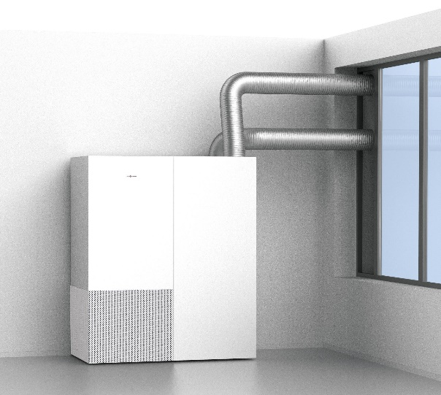

Image 1: Removes 99.99 percent of all viruses: the Vitovent 200-P hybrid ventilation unit from Viessmann cleans the ambient air and simultaneously supplies the room with fresh outside air.



Image 2: The Vitovent 200-P ventilation system continuously supplies up to 30 people per room with purified, fresh air using the displacement flow principle.

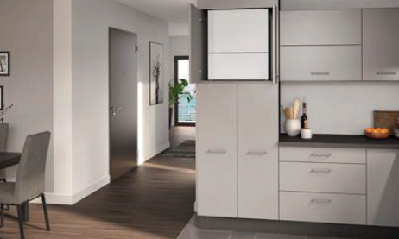

Image 3: The new Vitovent 300-W centralized home ventilation system with an air volume flow rate of 225 m3/h is designed for stand-alone operation in condos and smaller apartments in large residential complexes thanks to its compact dimensions.

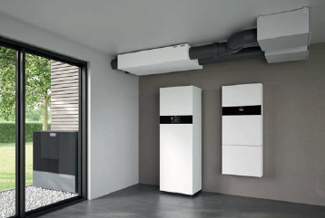

Image 4: Viessmann’s new Vitoair FS home ventilation system is one of the most compact units in its class, with an overall height of just 245 millimeters. The picture shows it with a Vitocal heat pump and the Vitocharge VX3 electricity storage system.

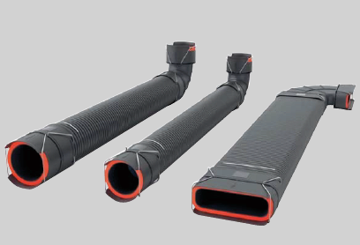

Image 5: The new Click and Go air distribution system from Viessmann for centralized home ventilation systems makes it particularly easy to lay its piping.

March 2021

Viessmann Climate Solutions SE

35107 Allendorf (Eder)

Phone: +49 (0)6452 702533

info-pr@viessmann.de

www.viessmann.de