Vitovent 100-D: Decentralized home ventilation for new and existing buildings
Controls fresh air – simply by app

Regardless of whether the house is brand new or is an older building with modernized energy systems, having an airtight building envelope generally makes it necessary to install controlled home ventilation, ensuring clean, fresh air in rooms – for the benefit of the people living there and to protect the building fabric from humidity and mildew. Requiring no ventilation channels, the Vitovent 100-D is a decentralized heating solution suitable for both single-family homes and large residential complexes. With the new Vitovent app, it is simplicity itself to operate the ventilation system via a smartphone. And now, with the addition of new accessories, it can be used in even more applications.

Ventilation with virtually no heat loss
The Vitovent 100-D decentralized home ventilation system allows individual rooms, sections of a home (ventilation zones) or an entire home to be ventilated with virtually no heat loss. Integrated heat recovery recoups up to 91 percent of the heat from the extract air and transfers it to the fresh air supply. This saves heating costs which reliance on conventional window ventilation would send sky high.
Heat recovery can be deactivated on hot summer days. Cool air is then fed to rooms on a targeted basis during the night.

Easy to operate via the Vitovent app (with voice command)
The ventilation system can be controlled either via the touch display of the central control element or, intuitively and easily, via the new Vitovent smartphone app – including by voice command, if desired. Target humidity and temperature values, as well as time programs, can be set for up to three ventilation zones in the house or apartment. Device status information – for example, regarding the need to change filters – is also displayed. The app can also be used to control the ventilation system using Amazon Alexa or Google Assistant.

Diffuser keeps traffic noise outside
Troublesome traffic noise? The Vitovent 100-D’s new diffuser is built almost invisibly into the window soffit, is really effective at dampening sound and keeps road traffic noise outside as much as possible. A traditional white restrictor together with two stainless steel restrictors (round or square) can also be supplied.

Ventilation of internal rooms now also possible
The Vitovent 100-D also succeeds easily in directly ventilating rooms that have no external walls. The product range is rounded off by extract air fans for peripheral rooms such as the bathroom and WC, and by the new Vitovent 100-D type E300 extract air fan. The unit effectively ventilates internal rooms and exhaust air via a customer-installed extractor shaft. Used in conjunction with a humidity sensor, the unit can operate fully automatically.

Easy installation and service
No ventilation channels are required for the Vitovent 100-D. At least two units are mounted into the walls after drilling a tap hole with a diameter of just 162 millimeters. These then alternate with each other, one of them conveying stale air outside while the other blows fresh air into the room. To make servicing as simple as possible, the unit can be accessed from inside the room without tools.

Advantages for trade partners
- Suitable for new buildings and modernization projects
- Needs very little space
- Easy installation through a 162 mm tap hole
- Intuitive and quick start-up procedure via touch display or app
- Complete system from a single source

Advantages for homeowners
- Inconspicuous appearance thanks to installation in window soffit
- Low operational noise levels and high degree of sound insulation to combat traffic noise
- Simple intuitive control via smartphone and the Vitovent app
- Set individual time programs and user profiles via the Vitovent app
- Can operate automatically with humidity, temperature and air quality sensors installed

Specifications
- Air volume flow rate up to 45 m³/hr.
- Heat recovery up to 91%
- Energy efficiency category: A (in manual mode), A+ (when operating in line with local needs)

Delivery date
The Vitovent 100-D decentralized ventilation system is already available. The diffuser for the window soffit and extract air fan for internal rooms will be available for delivery from April 2019. The Vitovent app will be available in the 4th quarter of 2019.

Images/captions
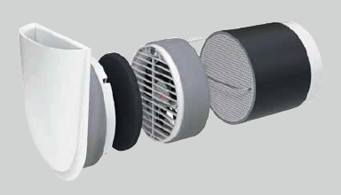
Image 1: Viessmann’s Vitovent 100-D decentralized home ventilation system ensures fresh, clean ambient air is supplied in both new builds and existing buildings.

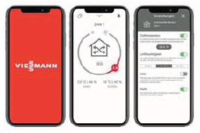
Image 2: Viessmann’s Vitovent 100-D can be controlled intuitively and easily via the new Vitovent smartphone app.

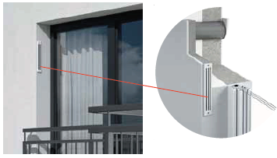
Image 3: The new diffuser for Viessmann’s Vitovent 100-D is built almost invisibly into the window soffit, is especially effective at dampening sound and keeps road traffic noise outside as much as possible.

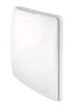
Image 4: The new Vitovent 100-D extract air fan is specially designed for ventilating internal rooms.

March 2019

Viessmann Werke GmbH & Co. KG
35107 Allendorf (Eder)
Tel.: +49 (0)6452 702533
info-pr@viessmann.de
www.viessmann.de

