Vitocal 350-G Pro: Large heat pump for high temperatures
Easy remote maintenance with new programmable logic controller

If you need high temperatures for hygienic DHW generation or for providing heat to radiator systems, the Vitocal 350-G Pro large heat pump is the right choice for you. With flow temperatures of up to 73 degrees Celsius, the pump enables large residential complexes, administration buildings, commercial buildings and communal facilities to be heated in an economical manner. The new Vitotronic SPS (type 2.0) programmable logic controller now makes operation and maintenance even easier – any time and from anywhere.

Comprehensive remote maintenance ensures high degree of availability
The new PLC-based Vitotronic makes it really easy to access your heat pump system quickly from any location, allowing you to optimize settings or rectify faults. The control unit boasts a wide range of communication options to aid system monitoring and remote maintenance. Apart from LAN-based systems, you can also use Modbus and Bacnet interfaces, which enable the heat pump to be integrated into a superordinate building management system. Up to four mixed heating or cooling circuits can be monitored and controlled. The system also includes an integrated control unit specifically for cooling operation which permits cold water levels to be regulated by means of waste heat management using geothermal probes or heat exchangers. As an option, the system can be adapted to include the facility to control an oil/gas-fired boiler and a DHW cylinders.
Local operation of the system is very straightforward using the large 7" color touch display attached directly to the heat pump. The heat pump can be operated intuitively without the need to have printed instructions to hand.
High efficiency means low energy costs
The output spectrum of the two or three-stage large heat pump ranges from 27 to 198 kilowatts when using geothermal energy. When using groundwater as a heat source, heat outputs between 37 and 274 kilowatts are available. The heat pump’s high efficiency (COP: 4.4 at B0/W35°C in accordance with EN 14511) is the ideal way of ensuring low power consumption and low energy costs, consistently allowing high flow temperatures to be achieved even at low heat-source temperatures.
Advantages for trade partners
- Two or three-stage design provides extensive output spectrum and optimal part-load behavior
- Equipped with electronic soft starter as standard
- PLC-supported Vitotronic with Modbus and Bacnet communication interface
- Multi-stage feature ensures increased operational reliability
- Cooling control unit with waste heat management via geothermal probe or heat exchanger
- Robust design (industrial design)
Advantages for homeowners
- Low operating costs thanks to high coefficient of performance
- Low-cost partial load operation by use of two or three equally powerful compressors
- Low noise and vibration emissions thanks to sound-optimized appliance design
- Intuitive, easy-to-use control unit via touchscreen and graphic display
- Reliability ensured by means of factory-adjusted heat test with functional and performance tests

Technical data
- Output: 27 - 198 kW (brine/water) and
37 - 274 kW (water/water)
- Flow temperature of up to 73°C
- COP up to 4.4 (at B0/W35°C in accordance with EN 14511)
- Length x width x height: 2816 x 911 x 1650 mm (type BW 353.B198)
- Weight: 1678 kg (type BW 353.B198)
- Energy efficiency category: A++
Market launch
The Vitocal 350-G Pro with new PLC-based Vitotronic will be available to order from August 2019.
Images/captions
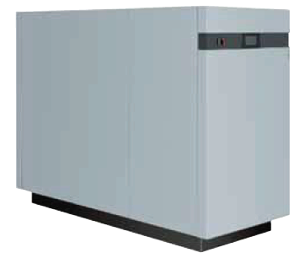
Image 1: Viessmann’s Vitocal 350-G Pro large heat pump is particularly suitable for hygienic DHW generation and radiator operation, delivering flow temperatures of up to 73°C.

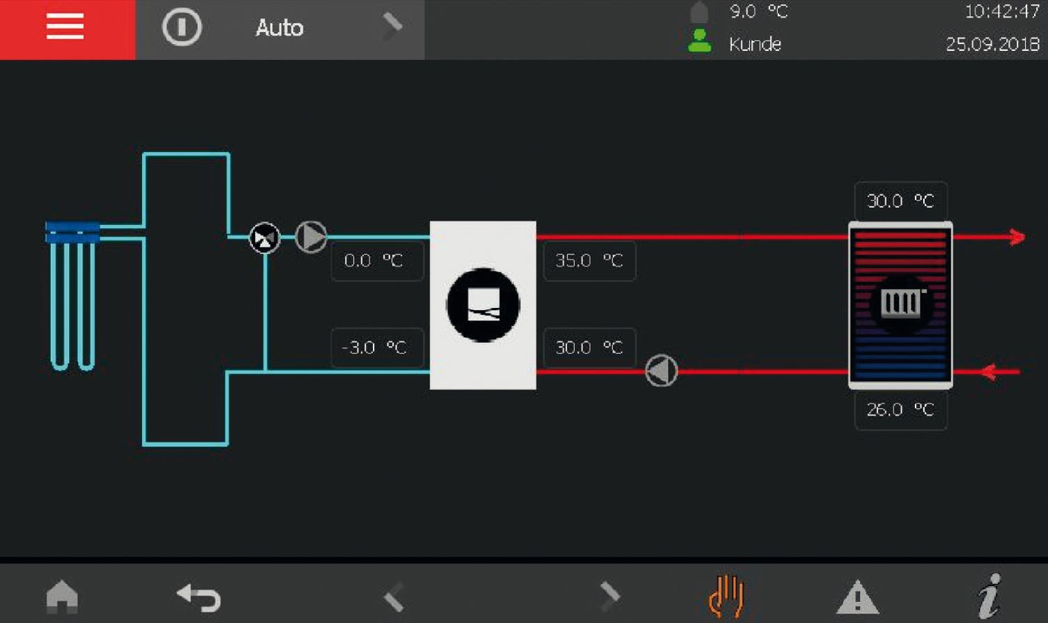
Image 2: The new Vitotronic PLC (type 2.0) with large 7" color touch display permits remote maintenance of Viessmann’s Vitocal 350-G Pro heat pump.
March 2019

Viessmann Werke GmbH & Co. KG
35107 Allendorf (Eder)
Tel.: +49 (0)6452 702533
info-pr@viessmann.de
www.viessmann.de

